Groundwater Flow Simulator

By P. Riemersma, GVSU Geology

Understanding groundwater is important as about half of all Michigan residents rely on groundwater either from municipal wells or their own personal wells. This week you will learn about groundwater flow through use of a groundwater simulator. Continuing the tradition of exposing you to state of the art high technology, this week you will learn how to use food coloring (technical term: dye) to monitor the direction of groundwater flow.

Groundwater Flow Simulator
The front face of the simulator (see Figure 1) is a geologic cross-section or profile of the subsurface. Behind the front aquifer compartment is a rear water reservoir compartment that stores water that is circulated through the aquifer compartment. Two different kinds of aquifers are represented by the model - an (upper) unconfined and a (lower) confined aquifer. The uppermost aquifer consists of fine sand underlain by a coarse sand layer and is called an unconfined aquifer. A low permeability confining layer or aquitard of clay overlies a confined aquifer that consists of coarse sand and gravel. Water enters the unconfined and confined aquifers along the right edge of the model and exits the model through the stream at the top of the left side. The vertical tubes in the well represent water wells, the tubes are only open (screened) at their base (white area in photo) and are open at different depths and sometimes in different aquifers. An important point to remember is that water levels in wells represent and record the hydraulic conditions where the wells are open!
Groundwater recharge areas are areas where groundwater flow is downward and groundwater discharge areas are where groundwater flow is upward. Discharge areas tend to be low topography areas such as wetlands, lakes and streams. If the water levels are higher in shallow wells compared to deeper wells in a cluster of wells screened at different depths, then the well is in a recharge area (downward component of flow). Therefore, if water levels are not the same in adjacent wells that are measuring different depths in the aquifer, we know that groundwater flow is not entirely horizontal - in other words there is some vertical component of groundwater.
The water table separates the unsaturated zone from the saturated zone in an unconfined aquifer and rises and falls depending on the amount of infiltration of water. A confined aquifer has a potentiometric surface, which is a representation of the level to which water will rise under pressure (above the top of the confined aquifer). An artesian well is a well that gets water from a confined aquifer. Water from a flowing well does not need to be pumped because the water level elevation is greater than the land surface elevation.
We will be measuring the hydraulic gradient (essentially the slope) of the water table using the static water levels in the shallow wells. We will also be injecting dye into the wells and creating elongate groundwater contamination plumes that will trace out the groundwater flow paths. We will also see the effect that pumping water from the wells has on the migration of the contaminated (dyed) water.
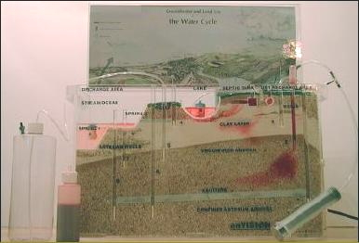

Experiment 1 Groundwater Flow Velocity

Introducing dye into the water allows us to observe and trace the direction that groundwater is flowing and also measure the groundwater flow velocity. In this experiment you are going to introduce some dye into the bottom of well 3 and trace and measure how fast groundwater is flowing. Then you will measure the hydraulic gradient, assume a porosity and use Darcy's Law to estimate the K value for the sediment that the groundwater traveled through.

1. Experimental Calculation of Groundwater Flow Velocity

Fill the syringe with a little bit of dye and push the syringe tube down into the bottom of well 3. Gently inject dye into the bottom of the well. Start your stopwatch and wait and see how long it takes your plume to travel about 15 cm away from well 3 (or some other distance, remember distance/time = velocity).

1a. Time _______
Distance _______
Experimental Determination of Groundwater Velocity ___________ cm/minute

1b. Take a look at a couple of the other flow models. Was the groundwater flow path for dye from well 3 for your model exactly the same as the other models?____________ If not, what are some reasons why the flow path may be slightly different for different models?

2. Estimation of Hydraulic Conductivity in Unconfined Aquifer

Measure the hydraulic gradient, select a porosity value between 25 - 50 %, use the velocity you calculated in question 1 and then use Darcy's law to calculate the K value for the sediment in the unconfined aquifer that your dye traveled through.

Darcy's Law is v = hydraulic gradient *K/porosity

where v is the groundwater flow velocity (cm/minute)

K is the hydraulic conductivity (cm/minute)

where porosity is in decimal form (20% = .2)

solving for K, K = velocity * porosity/hydraulic gradient

Use the difference in water levels between wells 3 and 4 and the distance between these two wells to calculate the hydraulic gradient. You can calculate the slope (hydraulic gradient) of this line by measuring the vertical distance in cm between the water level in well 3 and well 4 (see sketch below) divided by the horizontal distance between the two wells. It's probably easiest to measure the distance from the water level to the top of the model, and then subtract well 3 from well 4.

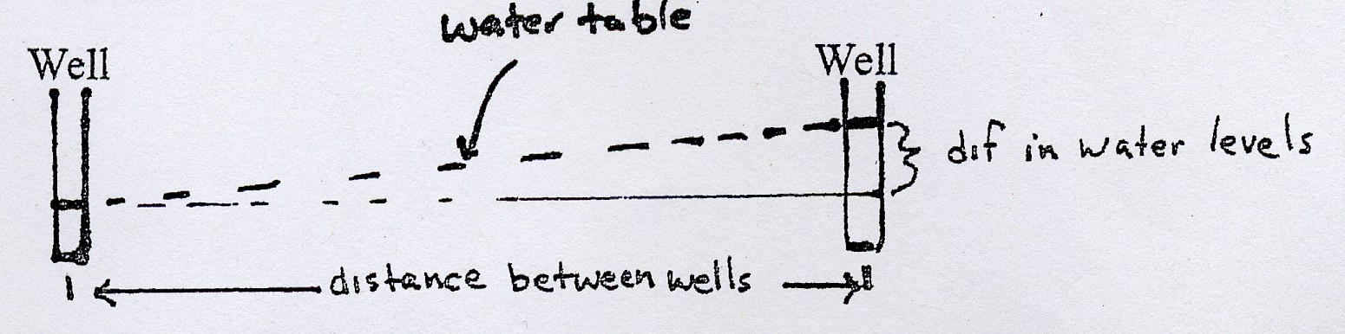

hydraulic gradient = difference in water levels (in centimeters)
-------------------------------- (divided by)
horizontal distance between two points in cm
2. Data Table
Hydraulic Gradient (your measurement) | Porosity (your estimate) | Unconfined aquifer GW velocity (cm/min) | Estimated Hydraulic conductivity (cm)

3. Experimental Calculation of Groundwater Flow Velocity in the Confined aquifer

Fill the syringe with a little bit of dye and push the syringe tube down into the bottom of confined well 1. Gently inject dye into the bottom of the well. Start your stopwatch and wait and see how long it takes your plume to travel about 20 cm away from well 1 (or some other distance, remember distance/time = velocity).

3. Time _______
Distance _______
Experimental Determination of Groundwater Velocity ___________

4. Estimation of Hydraulic Conductivity in Confined Aquifer

Measure the hydraulic gradient between the two wells in the confined aquifer, select a porosity value between 25 - 50 %, use the velocity you calculated in question 3 and then use Darcy's law to calculate the K value for the sediment in the confined aquifer that your dye traveled through.

Data Table
Hydraulic Gradient (your measurement) | Porosity (your estimate) | GW velocity (cm/min) | Estimated Hydraulic conductivity (cm)

5. Comparison of velocity and K values

5a. Velocity value unconfined aquifer __________________
Velocity value confined aquifer _____________________

Why was the velocity faster in the confined aquifer?_____________________

5b. K value unconfined aquifer ________________________
K value confined aquifer __________________________

5c. Did the hydraulic conductivity values you estimate fall within the range given below for the sediment grain size? ____________

Estimates of Porosity and Hydraulic Conductivity from Grain Size

Porosity Hydraulic conductivity

Gravel 25 - 40% 6 - 6000 cm/minute
Sand 25 - 50 % .06 - 60 cm/minute
Silt 35 - 50 % .00006 - .006 cm/minute
Clay 40 - 70% 10⁻⁹ - 10⁻⁶ cm/minute

Observations and Further Experiments using the Groundwater Flow Model

Differences between Confined and Unconfined Aquifers

6a) Are the water levels in the confined aquifer wells above the top of the confined aquifer (the top of the confined aquifer is just below the clay layer) ? _______

6b) Use a big syringe to force air down well 1 and watch what happens to wells 4 and 6. In which well does the water level change the most after forcing air down well 1? ___________________

6c) Why does the water level change the most in the well you identified in 6b?

7a) Circle the correct answer(s). Where does the water come from when you pump water from a confined aquifer?

1) pumping water out reduces the water pressure in the pores, causing the water to expand slightly and "overflow" the pore
2) pumping water out reduces the pressures in the pores, causing grain compaction and a small decrease in the size of the pore. Less water can be held in a smaller pore so water "overflows" out of the pores.
3) pumping water out drains pores of water, leaving the pore partially filled with water and air
4) pumping stimulates subsurface microorganisms to "transfer intestinally" groundwater into the well.
5) confined aquifers intersect underground rivers for their water

Using Nested Wells to Identify Groundwater Flow Directions

Note that the water levels in adjacent wells 2 and 3 are slightly different. Given that the wells are measuring the water pressure in the aquifer at a point at the bottom of the well, and because water flows from high water levels to low water levels, nested wells can be used to identify if groundwater flow has a downward or upward component.

8a) Sketch in what the water levels look like in the sketch below.

8b) From the water levels shown in your sketch, is groundwater flow near the wells upward or downward direction? __________ (compare to examples B and C)

8c) Are wells 2 and 3 in a recharge or discharge area? ____________

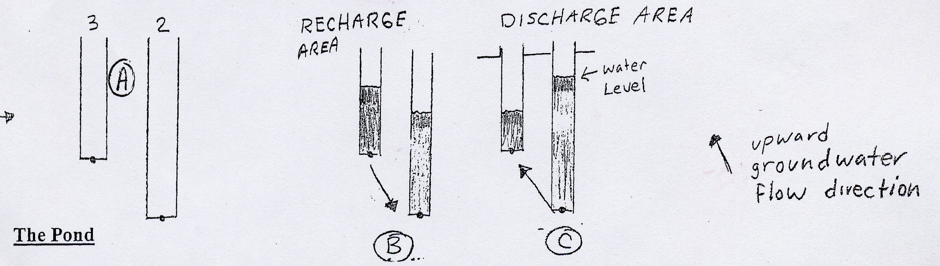

The Lake

With the exit valve closed, observe that the water table intersects the lake. In your groundwater model so far, your lake has acted as a flow through lake in that the lake receives groundwater from the right and loses lake water to the groundwater to the left. We'll experiment to see how changes in lake level affect the groundwater flow system.

9a) A heavy rain has added water to the lake and raised the water level! Unfortunately the nearby cattle feedlot has contaminated the runoff (gross). Simulate this event by adding dyed water to the pond for awhile, keeping the water level in the lake at a maximum while observing what is happening (while keeping the exit valve closed). Describe where the lake water goes now and why (especially look for changes occurring to the right of the lake)

9b) Heavy pumping of water out of the lake (to fill resident ponds and water gardens) has resulted in a sudden drop in lake levels. Put some dye in wells adjacent to the pond and then open the exit valve of the lake. Describe what happens and why>

